Stored Procedures
Stored Procedures (PL/SQL)
1️⃣ What is a stored procedure?
A stored procedure is a named PL/SQL program unit that is:
- stored in the database as a precompiled object
- compiled once, executed many times
- used for reusability, performance, and security
- explicitly executed by the user or an application

2️⃣ Types of procedures (conceptual)
🔹 Static procedure
- No parameters
- Always produces the same result
🔹 Dynamic procedure
- Uses parameters
- Output depends on input values

3️⃣ Structure of a procedure
A procedure has two parts:
1. Procedure specification (header)
- Name
- Parameters (IN / OUT / IN OUT)
2. Procedure body
- Declaration section (optional)
- Execution section (mandatory)

4️⃣ Static procedure (no parameters)
DROP PROCEDURE greetings;
/

CREATE OR REPLACE PROCEDURE greetings
IS
BEGIN
DBMS_OUTPUT.PUT_LINE('Welcome to PL/SQL Session!');
END;
/
How to execute a procedure
EXEC greetings;
or
EXECUTE greetings;
or
BEGIN
greetings;
END;
/

5️⃣ Procedure parameters (IN / OUT / IN OUT)
Parameter modes
Mode | Purpose
IN | Pass value into procedure (default)
OUT | Return value from procedure
IN OUT | Same variable used for input & output
There is no fixed limit on number of parameters (practical limits only).

6️⃣ Dynamic procedure (IN parameter)
CREATE OR REPLACE PROCEDURE greetings2 (
p_name IN VARCHAR2
)
IS
BEGIN
DBMS_OUTPUT.PUT_LINE('Welcome ' || p_name || ' to PL/SQL Session!');
END;
/
Execution
EXEC greetings2('James');
or
BEGIN
greetings2('John');
END;
/

7️⃣ Procedure with OUT parameter
CREATE OR REPLACE PROCEDURE total (
n1 IN NUMBER,
n2 IN NUMBER,
p_sum OUT NUMBER
)
IS
BEGIN
p_sum := n1 + n2;
END;
/
Calling the procedure
DECLARE
v_total NUMBER;
BEGIN
total(1230, 9920, v_total);
DBMS_OUTPUT.PUT_LINE('Total: ' || v_total);
END;
/

🔟 Key rules to remember
- Procedures do not return values (use OUT parameters)
- Functions return values
- IN parameters are read-only
- OUT parameters must be variables

🧠 One-line summary
A stored procedure is a reusable PL/SQL program stored in the database, executed explicitly, and can accept IN, OUT, or IN OUT parameters.

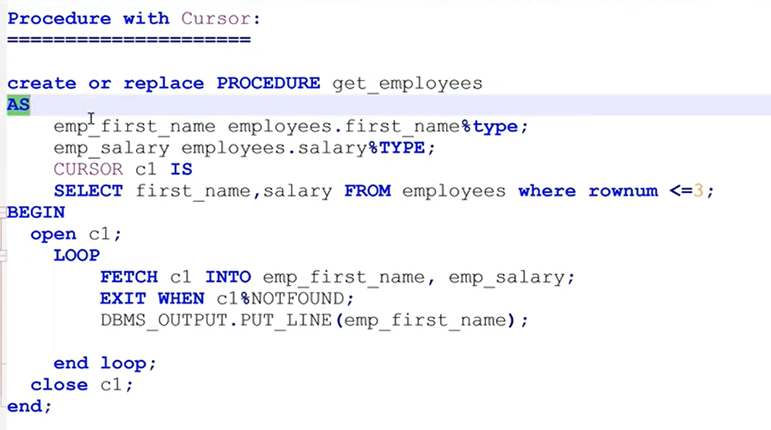

✅ Refactored Procedure Using a FOR Cursor Loop
CREATE OR REPLACE PROCEDURE get_employees
AS
BEGIN
FOR r IN (
SELECT first_name, salary
FROM employees
WHERE ROWNUM <= 3
)
LOOP
DBMS_OUTPUT.PUT_LINE(r.first_name || ' - ' || r.salary);
END LOOP;
END;
/

🔍 What was improved
- ❌ Removed explicit cursor (CURSOR, OPEN, FETCH, CLOSE)
- ✅ Oracle now manages cursor lifecycle automatically
- ✅ Cleaner, shorter, and safer code
- ✅ No risk of cursor leaks
- ✅ Best practice for simple row iteration

